Project Design Phase-II

Data Flow Diagram & User Stories

|  |  |
| --- | --- |
| Date | 29 October 2022 |
| Team ID | PNT2022TMID38920 |
| Project Name | Project – AI BASED DISCOURSE FOR BANKING INDUSTRY |
| Maximum Marks | 4 Marks |

# Data Flow Diagrams:

**LEVEL: 2**

**LEVEL: 1**

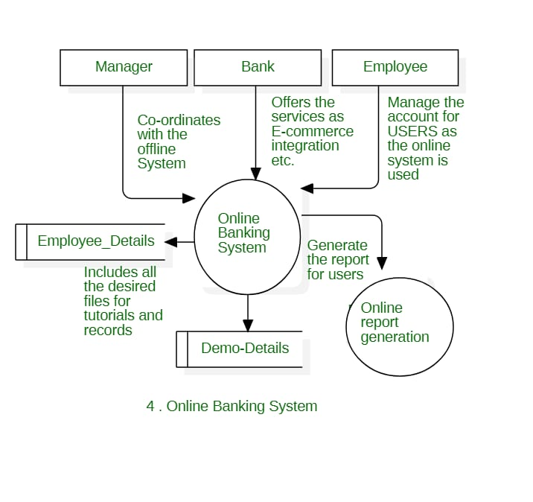

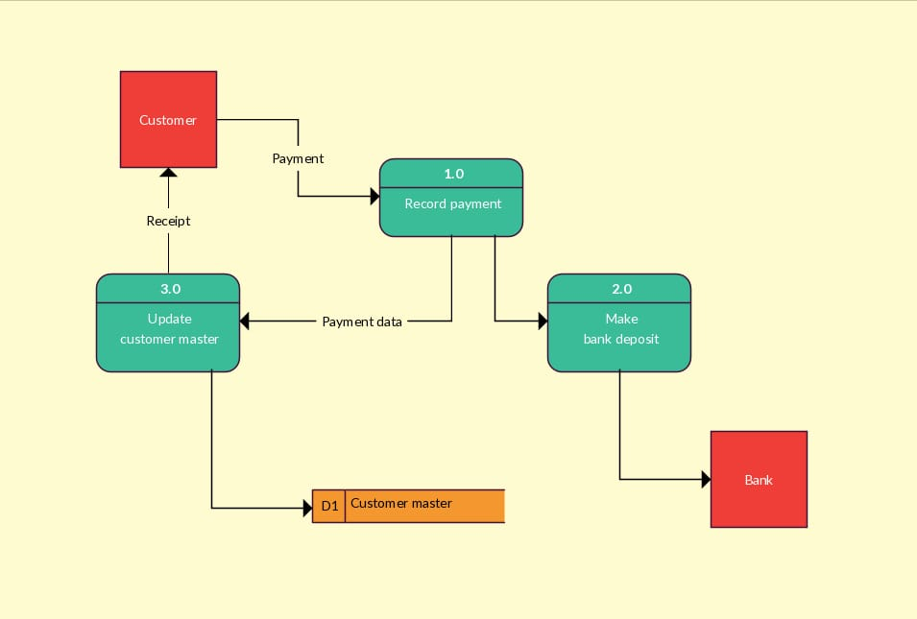

|  |  |  |  |  |  |  |
| --- | --- | --- | --- | --- | --- | --- |
| **User Type** | **Functional**  **Requirement (Epic)** | **User Story Number** | **User Story / Task** | **Acceptance criteria** | **Priority** | **Release** |
| Customer (Mobile or web user) | Savings Account  Related Actions | USN-1 | As a user, in the savings account option, I can select types of saving accounts to get details recording documents savings accounts. | I can clear my queries recording types of savings account | High | Sprint-1 |
|  |  | USN-2 | As a user, I can check the interest Rates of saving account. | I can clear my queries recording interest rates of saving account. | High | Sprint-1 |
|  |  | USN-3 | As a user, I can check the minimum balance of saving accounts. | I can clear my queries recording minimum balance of saving accounts. | Medium | Sprint-2 |
|  | Current Account Related Actions | USN-4 | As a user, I can choice the type of company to know the information on document to be submitted for creating current account. | I can clear my queries recording types of company. | High | Sprint-1 |
|  |  | USN-5 | As a user, I want to get detail on to close my current account. | I can clear my queries recording current account closure. | High | Sprint-2 |
|  | Loan Account Related Actions | USN-6 | As a user, I can choice the type of loans to known the information of choosing on essential loan schema. | I can clear my queries recording type of loan account. | High | Sprint-1 |
|  |  | USN-7 | As a user, I can check the loan account that can be offered for corresponding loan accounts chosen. | I can clear my queries recording loan amounts of loan accounts. | High | Sprint-2 |
|  |  | USN-8 | As a user, I can check the status of loan for my loan accounts. | I can clear my queries recording loan status loan accounts. | Low | Sprint-2 |
|  | General Queries Related Actions | USN-9 | As a user, I want to get the producer details for currently conversion of my bank account. | I can clear my queries recording currently conversion of my bank account. | Low | Sprint-1 |
|  |  | USN-10 | As a user, I want check my CIBIL score for my loan application to ensure whether my loan application is approved by the bank. | I can clear my queries recording CIBIL score of loan application. | Medium | Sprint-3 |
|  |  | USN-11 | As a user, I want to get the producer details for maintain storage of bank account. | I can clear my queries recording storage of bank account. | High | Sprint-3 |
|  | Net Banking Related Actions | USN-12 | As a user, I want to get the producers details are changing the net banking password of my bank account. | I can clear my queries recording chance of net banking password. | Medium | Sprint-2 |
|  |  | USN-13 | As a user, I want select type of transfer to get details recording difference service. | I can clear my queries recording types of transfer in net banking. | High | Sprint-2 |
| Administrator |  | USN-14 | As an admin, I can chance responses to queries modified them has and when needed. | I can modified responses of the chatbot. | Medium | Sprint-1 |
|  |  | USN-15 | As an admin, I can added more options to queries and added new options new get added. | I can added more options and queries into the chatbot. | Medium | Sprint-1 |